# Lab 3

## Exercise 1: Cross-Tabular Report

### **Lab Questions**

Answer the following questions using the report you created. (Do NOT include currency symbols or thousands separators). Do not use any level of filtering to answer the questions.

1. What is VanArsdel's sales for December 2013? (to two decimal places)
2. What is VanArsdel's total units for the March 2013? 

## Exercise 2: Part-to-Whole Report

### **Lab Question 1**

Answer the following questions using the report you created. (Do NOT include currency symbols or thousands separators). Do not use any level of filtering to answer the questions.

1. In January 2014, what is VanArsdel's sales, from all manufacturers, for Urban category and Moderation segment? (to two decimal places) (Hint: Try hovering on the chart) 
2. In May 2015, what is VanArsdel's sales, from all manufacturers, for Mix category and All Season segment? (to two decimal places) (Hint: Try hovering on the chart) 
3. Answer the following question by using the treemap chart you created.

For VanArsdel's sales in 2015, which are the top 4 manufacturers?

RIGHT ANSWER

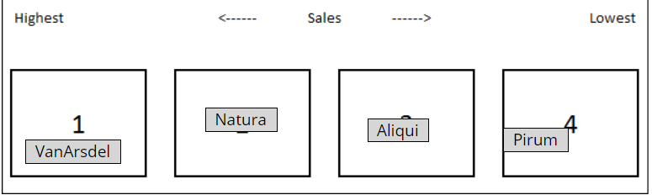

## Exercise 3: Relationship Report

### **Lab Questions**

As you can see, in the year 2015, Moderation segment made the most of VanArsdel's sales. It is not always the case. Use the Play Axis to investigate.

1. In which year the Moderation segment first took over as the segment with most sales?    
2. What about in terms of Units? In which year the Moderation segment first took over as the segment with most units?  

## Exercise 4: Trend Report

### **Lab Questions**

1. In which year the growth of total sales were not matched by the growth of total units?

2005

2006

2007

2008

1. Which year saw the biggest drop in total sales?

2007

2008

2009

2010

1. What about total units? Which year saw the biggest drop in total units?

2007

2008

2009

2010

## Exercise 5: Rank Report

### **Lab Questions**

1. What is the top product in terms of sales for the year 2010?

Maximus UM-92

Maximus UM-43

Maximus UM-70

Maximus UM-11

Maximus UC-69

1. What about in terms of units? What is the top product in terms of total units for the year 2010?

Maximus UM-92

Maximus UM-43

Maximus UM-70

Maximus UM-11

Maximus UC-69